**Assignment 2**

* **Creating Database:**

CREATE DATABASE sales_db

* **Creating Tables**

1. Salesman

CREATE TABLE salesman(

salesman_id INT PRIMARY KEY,

name VARCHAR(40),

city VARCHAR(15),

commission FLOAT NOT NULL

);

1. Customer

CREATE TABLE customer(

customer_id INT PRIMARY KEY,

cust_name VARCHAR(40),

city VARCHAR(15),

grade INT NOT NULL,

salesman_id int,

FOREIGN KEY (salesman_id) REFERENCES salesman(salesman_id)

);

1. Orders

CREATE TABLE orders(

order_no INT PRIMARY KEY,

purch_amt FLOAT NOT NULL,

ord_date DATE,

customer_id INT,

salesman_id INT,

FOREIGN KEY (customer_id) REFERENCES customer(customer_id),

FOREIGN KEY (salesman_id) REFERENCES salesman(salesman_id)

);

* **Queries**

1. SELECT S.name, C.cust_name, S.city

FROM salesman S

JOIN customer C

ON S.city = C.city

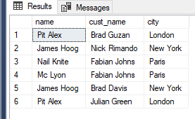

1. SELECT O.ord_no, O.purch_amt, C.cust_name, C.city

FROM orders O

JOIN customer C

ON O.customer_id = C.customer_id

WHERE purch_amt > 500 AND purch_amt < 2000;

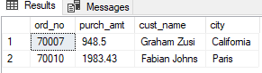

1. SELECT C.cust_name AS "Customer Name",

C.city,

S.name AS "Salesman",

S.commission

FROM salesman S

JOIN customer C

ON S.salesman_id = C.salesman_id

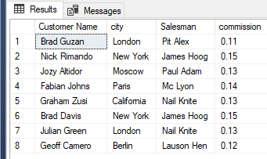

1. SELECT C.cust_name AS "Customer Name",

C.city,

S.name AS "Salesman",

S.commission

FROM salesman S

JOIN customer C

ON S.salesman_id = C.salesman_id

WHERE S.commission > 0.12

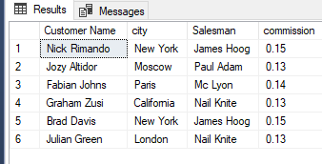

5)

SELECT C.cust_name AS "Customer Name",

C.city,

S.name AS "Salesman",

S.city,

S.commission

FROM salesman S

JOIN customer C

ON S.salesman_id = C.salesman_id

WHERE S.commission > 0.12 AND S.city != c.city

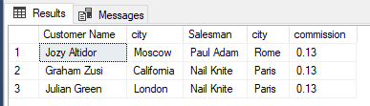

6)

SELECT O.ord_no, O.ord_date,

O.purch_amt,

C.cust_name AS "Customer Name",

C.grade,

S.name AS "Salesman",

S.commission

FROM salesman S

JOIN customer C

ON S.salesman_id = C.salesman_id

JOIN orders O

ON S.salesman_id = O.salesman_id;

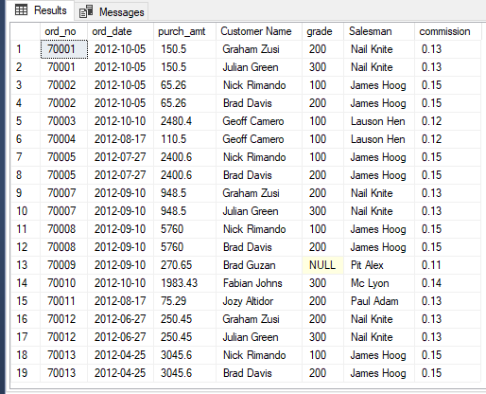

7)

SELECT *

FROM customer C, salesman S, orders O

WHERE C.salesman_id = S.salesman_id

AND C.customer_id = O.customer_id

AND C.city = S.city;

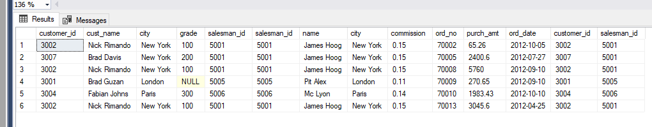

8) SELECT C.cust_name AS "Customer Name",

C.city,

C.grade,

S.name AS "Salesman",

S.city

FROM salesman S

JOIN customer C

ON S.salesman_id = C.salesman_id

ORDER BY C.customer_id

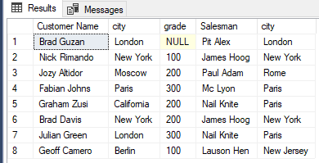

9)

SELECT C.cust_name AS "Customer Name",

C.city,

C.grade,

S.name AS "Salesman",

S.city

FROM salesman S

JOIN customer C

ON S.salesman_id = C.salesman_id

WHERE C.grade < 300

ORDER BY C.customer_id;

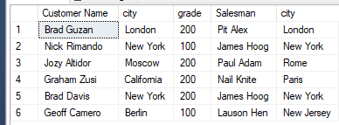

10)

SELECT C.cust_name AS "Customer Name",

C.city,

O.ord_no,

O.ord_date,

O.purch_amt

FROM customer C

LEFT JOIN orders O

ON C.customer_id = O.customer_id

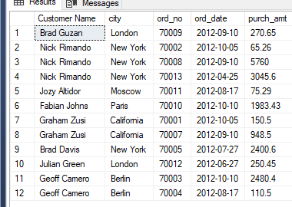

11)

SELECT C.cust_name AS "Customer Name",

C.city,

O.ord_no,

O.ord_date,

O.purch_amt,

S.name,

S.commission

FROM customer C

LEFT JOIN orders O

ON C.customer_id = O.customer_id

LEFT JOIN salesman S

ON C.salesman_id = S.salesman_id;

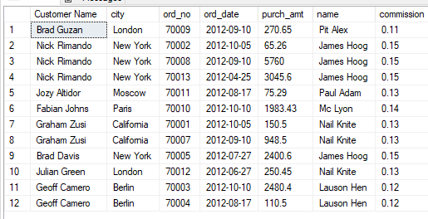

12)

SELECT S.salesman_id, S.name, C.customer_id, C.cust_name

FROM salesman S

LEFT JOIN customer C

ON C.salesman_id = S.salesman_id

ORDER BY S.name;

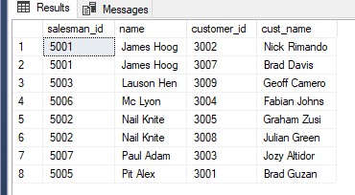

13)

SELECT S.name,

C.cust_name,

C.city,

C.grade,

O.ord_no,

O.ord_date,

O.purch_amt

FROM salesman S

JOIN customer C

ON S.salesman_id = c.salesman_id

JOIN orders O

ON C.customer_id = O.customer_id;

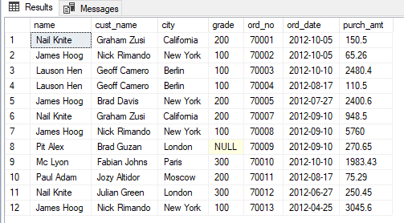

14)

SELECT S.salesman_id, S.name, C.customer_id, O.ord_no, purch_amt

FROM salesman S

LEFT JOIN customer C

ON C.salesman_id = S.salesman_id

LEFT JOIN orders O

ON O.customer_id = C.customer_id

WHERE O.purch_amt > 2000 AND C.grade IS NOT NULL;

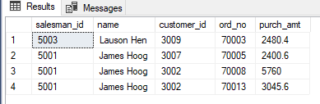

15) Same as 14

16)

SELECT C.cust_name, C.city,

O.ord_no, O.ord_date, O.purch_amt

FROM customer C

RIGHT JOIN orders O

ON C.customer_id = O.customer_id;

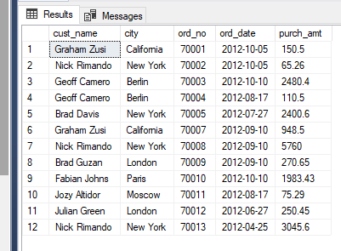

17)

SELECT *

FROM salesman

CROSS JOIN customer;

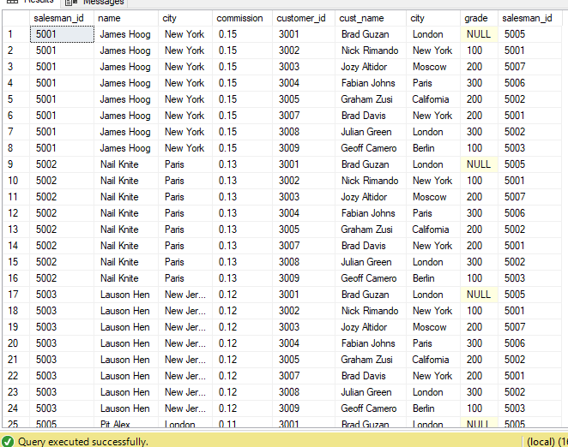

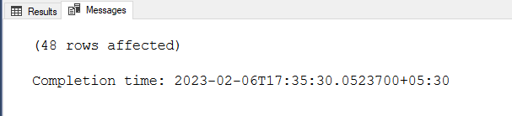

18)

SELECT *

FROM salesman S

CROSS JOIN customer C

WHERE S.city IS NOT NULL;

OUTPUT SAME AS 17

19)SELECT *

FROM salesman S

CROSS JOIN customer C

WHERE S.city IS NOT NULL

AND C.grade IS NOT NULL;

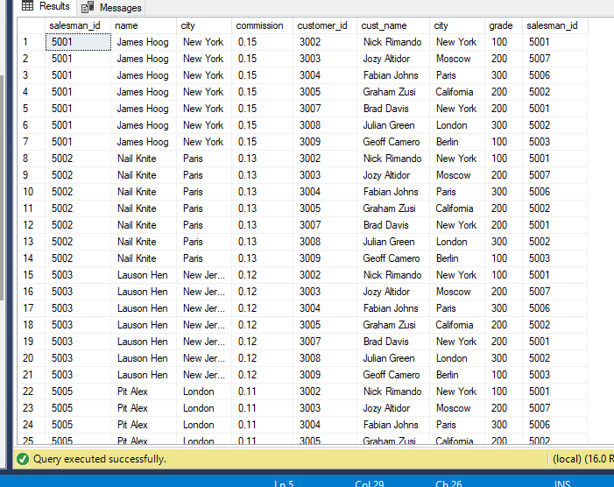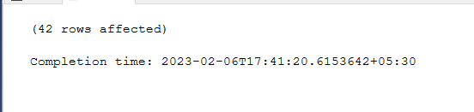

20)

SELECT *

FROM salesman S

CROSS JOIN customer C

WHERE S.city IS NOT NULL

AND C.grade IS NOT NULL

AND S.city != C.city;

